Week 6 – white box testing:
Statement coverage (robot face – mechanical, not the best metric)
- Have you written enough tests to test that every line of code is executed
- Doesn’t care how many times loops are executed
- Doesn’t care about the order they are executed
- Else’s are part of if (if-else counts as 1 statement)
- Def func() counts as 1 statement
+ easy to measure
+ easy to improve – know which lines to ensure are being executed
- same line of code can be executed in multiple ways (100% coverage if loop runs once, but wouldn’t recognise if the bug is when the loop runs > once)
- risk focusing too much on getting 100%

Branch/decision coverage ( :/ )
- Each case/if statements’ outcomes are checked
- # branches = (#ifs + #elifs)*2 (else covered under if)
+ better than statement coverage, coz meaningful checks

+ easy to measure
+ easy to improve
- only checking what is there
- ridiculous # tests
- doesn’t consider elements of a decision
- risk focusing too much on getting 100%
- doesn’t work if no branches

Condition coverage
- Each condition of branches’ outcomes are checked

Condition/decision coverage
- Combines condition and decision coverage
+ More meaning than either on its own
+ easy to measure
+ easy to improve
- results in some redundant tests given the overall functionality
- doesn’t work if no branches

Total coverage
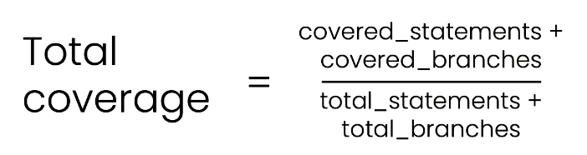

Short circuit evaluation affects condition coverage:
If we are testing b, the test must have a=True
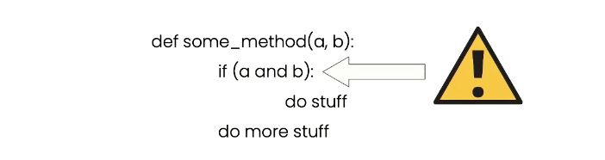

Statement coverage harder to measure in pythonic code:
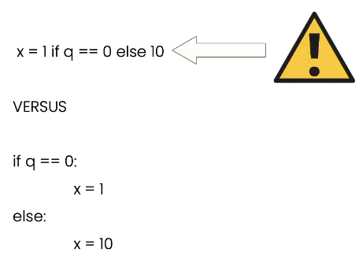

Code being tested:
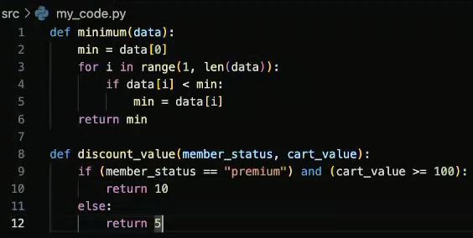

Test:
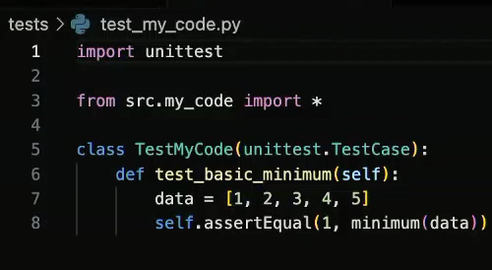

To run tests: “python -m unittest -v”
To run and generate coverage report on tests: “coverage -m unittest -v”
- Calcs stats on the backend (.coverage file)
- Annoyingly shows tests and src files coverage
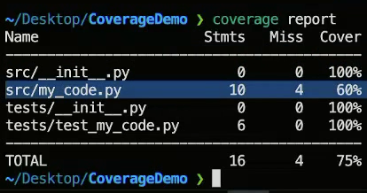
To read report: “coverage report”

To run and generate coverage report on tests on src files (+init) only: “coverage run --source=src -m unittest -v”
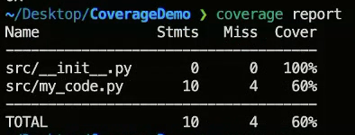
To exclude init: “coverage report --skip-empty -m”
- “-m” tells you which lines haven’t been tested (e.g. below is 5,9-12)
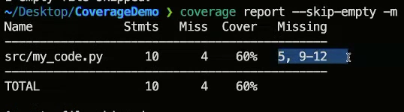

To get branch & total coverage metrics: “coverage --branch --source=src -m unittest -v”
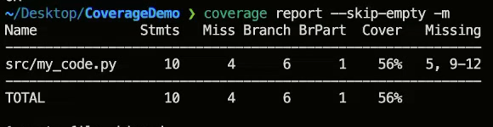

Better alternative to view report: “coverage html --skip--empty” and “open .”
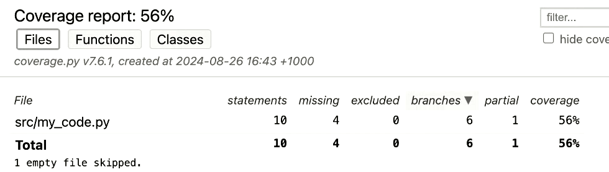
Click on “src/my_code.py” to see missing lines and branches
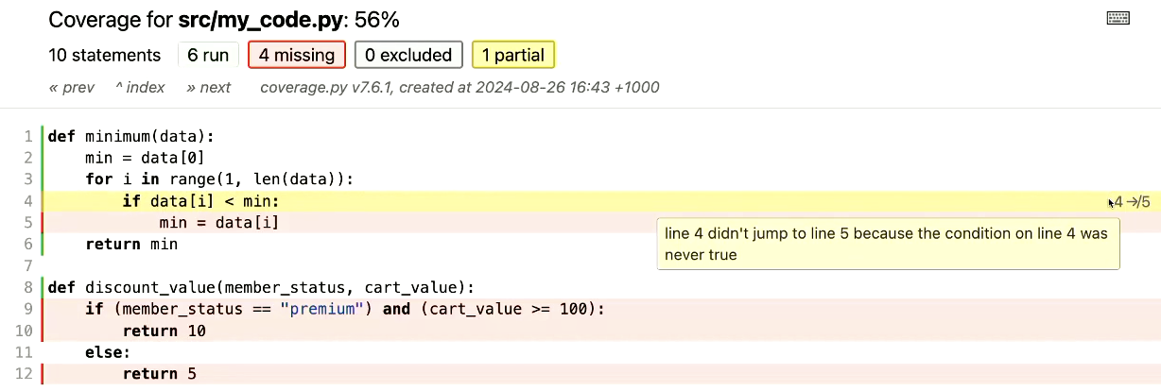
Summary
Remember that calculating your test coverage is a two step process:
- Run the tests.
- Create a coverage report.
Here are the commands you will use most often with Coverage.py. Don't forget to cd into the project folder first!
- coverage run --source=src -m unittest -v: run all the tests in the "src" folder, calculating statement coverage.
- coverage run --branch --source=src -m unittest -v: same as above, but include branch coverage.
- coverage report --skip-empty: show a coverage report in the terminal, skipping empty files (like the python init files).
- coverage report --skip-empty -m: same as above, but include a list of which lines of code were not covered.
- coverage html: generate a html report of your coverage results.

